Promote your event via email
COPY AND PASTE or DOWNLOAD this email template to invite friends, family and your broader community to your platypus spotting event. It is just a guide – rewrite and personalize it as much as you like.

Email Content

Sender: [Your Name], ACF Community XX
Subject: Join us to look for a platypus this Spring!

Hi [Name],

I’m taking part in the platy-project by heading down to a local waterway and trying to spot a platypus, along with ACF Community XX – and I’d love if you could join me!

In collaboration with the University of New South Wales, ACF is launching the Platy-Project in September and October for the fifth year in a row. The Platy-Project is a citizen science initiative that encourages nature lovers to head out to their local river or stream to see if they can spot our monotreme mates in the wild!

With platypus populations sadly declining, we can play an important role helping platypus researchers better understand where this much-loved (but very elusive) animal lives, and how they can be better protected.

It’s also just a great opportunity to get some fresh air and enjoy being in nature together.

What: [event name] e.g. Platypus spotting and picnic at King Valley Creek
When: [time and date]
Where: [meeting location]
RSVP here: [insert event link]

Platy-spotters at an ACF Community event in Templestowe, 2023. Photo: D Hudspeth.
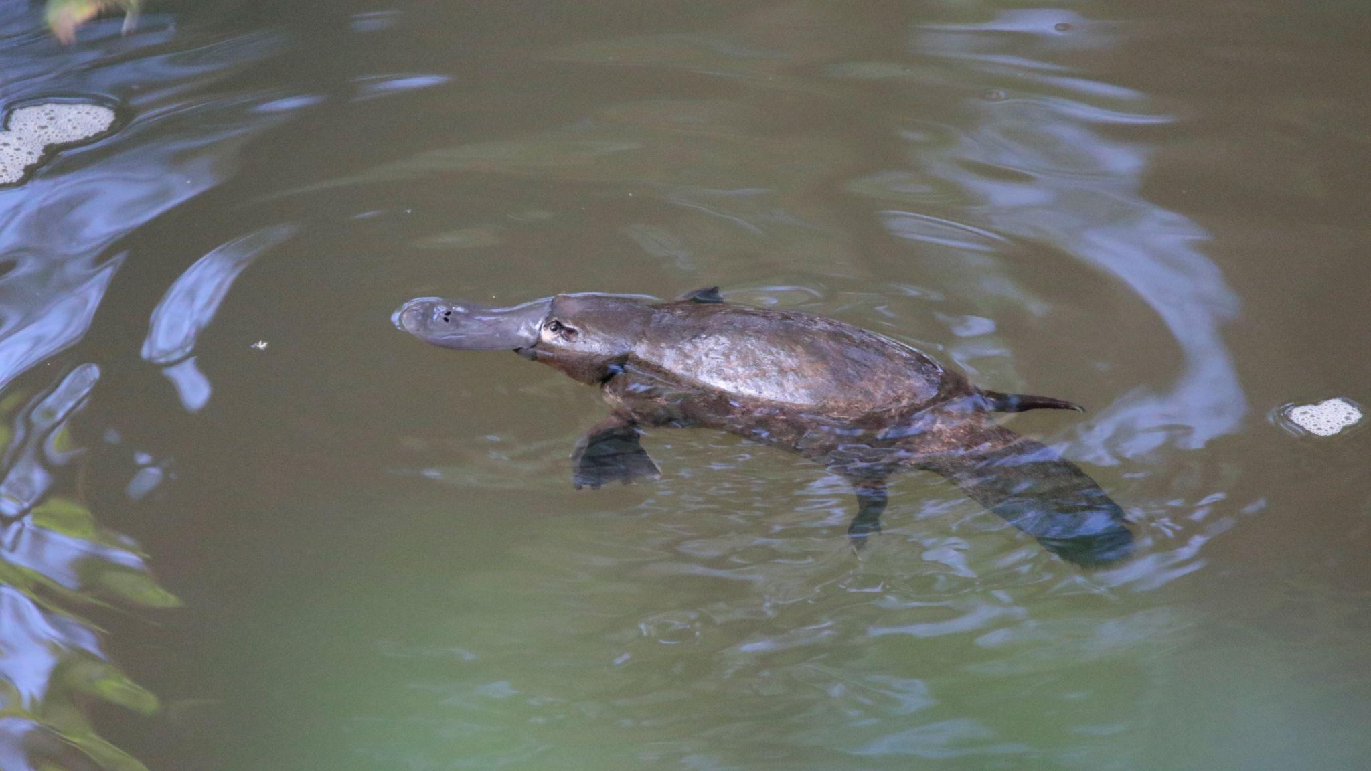
Photo submitted to the platy-project by N. Andison in 2022

On the day, you’ll become a citizen scientist by adding your observations to our national Platy Map, and help UNSW researchers build the most comprehensive picture of platypus populations to date.

I hope you’ll be able to join me at my platypus spotting event.

See you there!

[Your Name]
[Your group/org’s name]

P.S. Can’t make it the event but still want to look for a platypus? Sign-up to take part in the platy-project and get all the resources and tips you need to go platypus spotting yourself this September and October.

