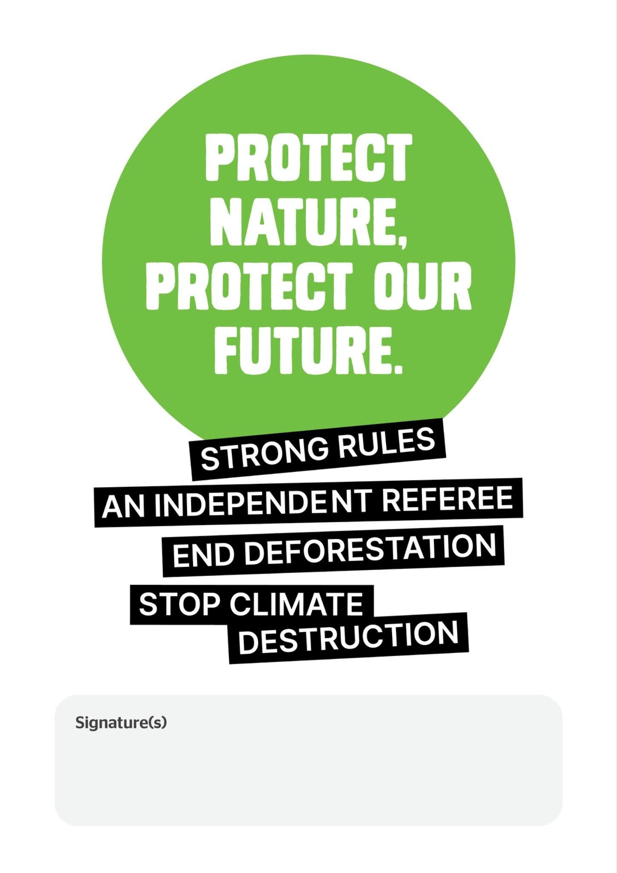

Dear

Protect nature; protect our future.
The Environment Minister Murray Watt has announced he’ll introduce new nature laws into Parliament by the end of this year.
The Government can get this right by creating laws that stop extinctions, support healthy communities, protect jobs and make sure the land, water and air we all depend on are healthy and thriving.
We, the undersigned, are calling on you to ensure the government tables laws that:

Set strong rules for nature protection.
By getting the rules right we can protect the homes of threatened animals and the livelihoods that depend on nature thriving.

Establish an independent Environment Protection Agency (EPA)
To make sure the rules are enforced; communities can speak up and keep political interference out of decision making. A well-resourced and impartial EPA will ensure Australia makes the best science-based decisions for nature and people.

Close deforestation loopholes.
Industry must be prevented from getting a free pass to bulldoze Australia’s forests and woodlands.

Factor climate harm into all decisions

Communities and wildlife must be protected from increasingly frequent and more extreme reef bleaching, algae blooms and dangerous weather that’s being turbo charged by burning coal and gas.
The Albanese Government’s second term is their chance to deliver strong laws for people and nature that all Australians can be proud of.
We’re counting on you to do everything in your power to make sure people and nature can thrive. We can get this right.
Dear

We, the undersigned, are calling on you to ensure the government tables laws that:
- Set strong rules for nature protection.
- Establish an independent Environment Protection Agency (EPA).
- Close deforestation loopholes.
- Factor climate harm into all decisions.

Provide your details so we can keep you updated on the campaign.

First name | Last name | Email | Phone | Postcode | I want to join my local ACF Community Group

We will always respect your privacy: acfonline.org.au/privacy-policy
We will pass on your name and contact details to your MP when delivering this letter

